WEEK 1

MODULE 1 : Design Pattern and Principles

NAME : Nishanth P

Exercise 1 : Implementing the Singleton Pattern

Given Scenario :

You need to ensure that a logging utility class in your application has only one instance throughout the application lifecycle to ensure consistent logging

Code:

Logger.java:

public class Logger {

private static Logger instance;

private Logger() {
System.out.println("Logger initialized successfully...");
}

public static Logger getInstance() {

if (instance == null) {
instance = new Logger();
}

return instance;
}

public void log(String msg) {

System.out.println(msg);
}
}

Main.java:

public class Main {

public static void main(String[] args) {

Logger logger1 = Logger.getInstance();
logger1.log("First log message");

Logger logger2 = Logger.getInstance();
logger2.log("Second log message");

System.out.println("Same instance? " + (logger1 == logger2));
}
}

OUTPUT:

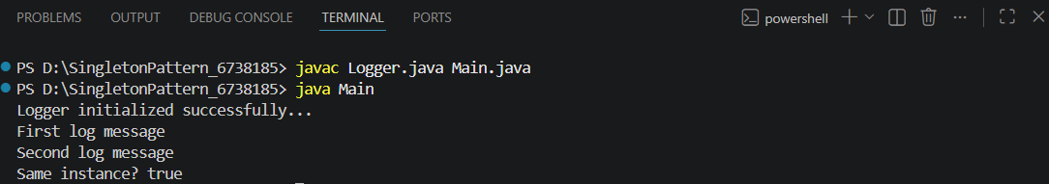

Exercise 2: Implementing the Factory Method Pattern

Given Scenario:

You are developing a document management system that needs to create different types of documents (e.g., Word, PDF, Excel). Use the Factory Method Pattern to achieve this.

Code:

Document.java:

public interface Document {
void open();
}

WordDocument.java:

public class WordDocument implements Document {
@Override
public void open() {
System.out.println("Opening Word Document...");
}
}

PdfDocument.java:

public class PdfDocument implements Document {
@Override
public void open() {
System.out.println("Opening PDF Document...");
}
}

ExcelDocument.java

public class ExcelDocument implements Document {
@Override
public void open() {
System.out.println("Opening Excel Document...");
}
}

DocumentFactory.java

public abstract class DocumentFactory {
public abstract Document createDocument();
}

WordFactory.java:

public class WordFactory extends DocumentFactory {
@Override
public Document createDocument() {
return new WordDocument();
}
}

PdfFactory.java:

public class PdfFactory extends DocumentFactory {
@Override
public Document createDocument() {
return new PdfDocument();
}
}

ExcelFactory.java:

public class ExcelFactory extends DocumentFactory {
@Override
public Document createDocument() {
return new ExcelDocument();
}
}

Main.java:

public class Main {
public static void main(String[] args) {
DocumentFactory wordFactory = new WordFactory();
Document word = wordFactory.createDocument();
word.open();
DocumentFactory pdfFactory = new PdfFactory();
Document pdf = pdfFactory.createDocument();
pdf.open();
DocumentFactory excelFactory = new ExcelFactory();
Document excel = excelFactory.createDocument();
excel.open();
}
}

Output:

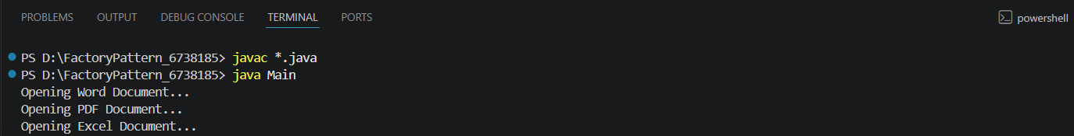

Exercise 3: Implementing the Builder Pattern

Scenario:

You are developing a system to create complex objects such as a Computer with multiple optional parts. Use the Builder Pattern to manage the construction process.

Code:

Computer.java:

public class Computer {

private String CPU;
private String RAM;
private String Storage;

private Computer(Builder builder) {

this.CPU = builder.CPU;
this.RAM = builder.RAM;
this.Storage = builder.Storage;
}

public void display() {

System.out.println("CPU: " + CPU);
System.out.println("RAM: " + RAM);
System.out.println("Storage: " + Storage);
}

public static class Builder {

private String CPU;
private String RAM;
private String Storage;

public Builder setCPU(String CPU) {
this.CPU = CPU;
return this;
}

public Builder setRAM(String RAM) {
this.RAM = RAM;
return this;
}

public Builder setStorage(String Storage) {
this.Storage = Storage;
return this;
}

public Computer build() {
return new Computer(this);
}
}
}

Main.java:

public class Main {

public static void main(String[] args) {

Computer gamingPC = new Computer.Builder()
.setCPU("Intel i9")
.setRAM("32GB")
.setStorage("2TB SSD")
.build();

System.out.println("Gaming PC Configuration:");
gamingPC.display();

System.out.println();

Computer officePC = new Computer.Builder()
.setCPU("Intel i5")
.setRAM("8GB")
.setStorage("512GB SSD")
.build();

System.out.println("Office PC Configuration:");
officePC.display();
}
}

Output:

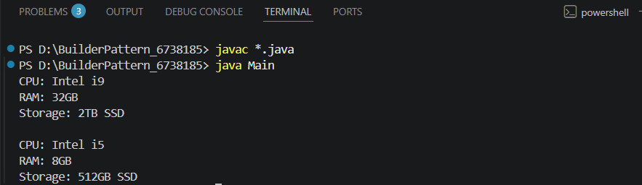
Exercise 4: Implementing the Adapter Pattern

Scenario:

You are developing a payment processing system that needs to integrate with multiple third-party payment gateways with different interfaces. Use the Adapter Pattern to achieve this.

Code:

PaymentProcessor.java

public interface PaymentProcessor {
void processPayment(double amount);
}

PayPalGateway.java

public class PayPalGateway {
public void sendPayment(double amount) {
System.out.println("Processing PayPal payment: ₹" + amount);
}
}

StripeGateway.java

public class StripeGateway {
public void makeCharge(double amount) {
System.out.println("Processing Stripe payment: ₹" + amount);
}
}

PayPalAdapter.java

public class PayPalAdapter implements PaymentProcessor {
private PayPalGateway payPalGateway;
public PayPalAdapter(PayPalGateway payPalGateway) {
this.payPalGateway = payPalGateway;
}
@Override
public void processPayment(double amount) {
payPalGateway.sendPayment(amount);
}
}

StripeAdapter.java

public class StripeAdapter implements PaymentProcessor {
private StripeGateway stripeGateway;
public StripeAdapter(StripeGateway stripeGateway) {
this.stripeGateway = stripeGateway;
}
@Override
public void processPayment(double amount) {
stripeGateway.makeCharge(amount);
}
}

AdapterPatternTest.java

public class AdapterPatternTest {
public static void main(String[] args) {
PaymentProcessor paypal =
new PayPalAdapter(new PayPalGateway());
PaymentProcessor stripe =
new StripeAdapter(new StripeGateway());
paypal.processPayment(5000);
stripe.processPayment(3000);
}
}

Main.java:

public class Main {
public static void main(String[] args) {

StripeGateway stripe = new StripeGateway();
PaymentProcessor stripeProcessor = new StripeAdapter(stripe);
stripeProcessor.processPayment(150.0);

PayPalGateway paypal = new PayPalGateway();
PaymentProcessor paypalProcessor = new PayPalAdapter(paypal);
paypalProcessor.processPayment(300.0);
}
}

Output:

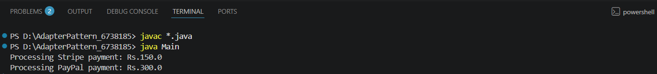

Exercise 5: Implementing the Decorator Pattern

Scenario:

You are developing a notification system where notifications can be sent via multiple channels (e.g., Email, SMS). Use the Decorator Pattern to add functionalities dynamically

Code:

Notifier.java:

public interface Notifier {
void send();
}

EmailNotifier.java:

public class EmailNotifier implements Notifier {
@Override
public void send() {
System.out.println("Sending notification via Email");
}
}

NotifierDecorator.java:

public abstract class NotifierDecorator implements Notifier {
protected Notifier notifier;
public NotifierDecorator(Notifier notifier) {
this.notifier = notifier;
}
@Override
public void send() {
notifier.send();
}
}

SMSNotifierDecorator.java:

public class SMSNotifierDecorator extends NotifierDecorator {
public SMSNotifierDecorator(Notifier notifier) {
super(notifier);
}
@Override
public void send() {
super.send();
System.out.println("Sending notification via SMS");
}
}

SlackNotifierDecorator.java:

public class SlackNotifierDecorator extends NotifierDecorator {
public SlackNotifierDecorator(Notifier notifier) {
super(notifier);
}
@Override
public void send() {
super.send();
System.out.println("Sending notification via Slack");
}
}

DecoratorPatternTest.java:

public class DecoratorPatternTest {
public static void main(String[] args) {
System.out.println("Email Notification:");
Notifier emailNotifier = new EmailNotifier();
emailNotifier.send();
System.out.println("\nEmail + SMS Notification:");
Notifier smsNotifier =
new SMSNotifierDecorator(new EmailNotifier());
smsNotifier.send();
System.out.println("\nEmail + SMS + Slack Notification:");
Notifier allNotifier =
new SlackNotifierDecorator(
new SMSNotifierDecorator(
new EmailNotifier()));
allNotifier.send();
}
}

Output:

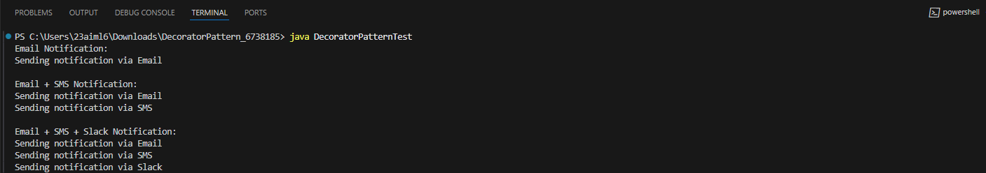
Exercise 6: Implementing the Proxy Pattern

Scenario:

You are developing an image viewer application that loads images from a remote server. Use the Proxy Pattern to add lazy initialization and caching.

Code:

Image.java:

public interface Image {
void display();
}

RealImage.java:

public class RealImage implements Image {
private String fileName;
public RealImage(String fileName) {
this.fileName = fileName;
loadFromServer();
}
private void loadFromServer() {
System.out.println("Loading image from remote server: " + fileName);
}
@Override
public void display() {
System.out.println("Displaying image: " + fileName);
}
}

ProxyImage.java:

public class ProxyImage implements Image {
private RealImage realImage;
private String fileName;
public ProxyImage(String fileName) {
this.fileName = fileName;
}
@Override
public void display() {
// Lazy Initialization
if (realImage == null) {
realImage = new RealImage(fileName);
}
// Cached object is reused
realImage.display();
}
}

ProxyPatternTest.java:

public class ProxyPatternTest {
public static void main(String[] args) {
Image image = new ProxyImage("Nature.jpg");
System.out.println("First Display:");
image.display();
System.out.println("\nSecond Display:");
image.display();
}
}

Output:

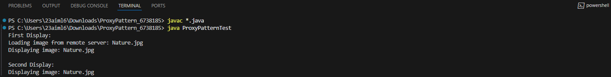
Exercise 7: Implementing the Observer Pattern

Scenario:

You are developing a stock market monitoring application where multiple clients need to be notified whenever stock prices change. Use the Observer Pattern to achieve this.

Code:

Stock.java:

public interface Stock {
void registerObserver(Observer observer);
void deregisterObserver(Observer observer);
void notifyObservers();
}

Observer.java:

public interface Observer {
void update(String stockName, double stockPrice);
}

StockMarket.java:

import java.util.ArrayList;
import java.util.List;
public class StockMarket implements Stock {
private List<Observer> observers = new ArrayList<>();
private String stockName;
private double stockPrice;
@Override
public void registerObserver(Observer observer) {
observers.add(observer);
}
@Override
public void deregisterObserver(Observer observer) {
observers.remove(observer);
}
@Override
public void notifyObservers() {
for (Observer observer : observers) {
observer.update(stockName, stockPrice);
}
}
public void setStockData(String stockName, double stockPrice) {
this.stockName = stockName;
this.stockPrice = stockPrice;
System.out.println("\nStock Updated:");
System.out.println("Stock: " + stockName);
System.out.println("Price: ₹" + stockPrice);
notifyObservers();
}
}

MobileApp.java:

public class MobileApp implements Observer {
private String userName;
public MobileApp(String userName) {
this.userName = userName;
}
@Override
public void update(String stockName, double stockPrice) {
System.out.println(
"Mobile App (" + userName +
") received update: " +
stockName + " = ₹" + stockPrice
);
}
}

WebApp.java:

public class WebApp implements Observer {
private String userName;
public WebApp(String userName) {
this.userName = userName;
}
@Override
public void update(String stockName, double stockPrice) {
System.out.println(
"Web App (" + userName +
") received update: " +
stockName + " = ₹" + stockPrice
);
}
}

ObserverPatternTest.java:

public class ObserverPatternTest {
public static void main(String[] args) {
StockMarket stockMarket = new StockMarket();
Observer mobileUser = new MobileApp("Ananth");
Observer webUser = new WebApp("Karthik");
stockMarket.registerObserver(mobileUser);
stockMarket.registerObserver(webUser);
stockMarket.setStockData("TCS", 4200.50);
stockMarket.setStockData("Infosys", 1650.75);
stockMarket.deregisterObserver(webUser);
System.out.println("\nWeb App Observer Removed");
stockMarket.setStockData("Wipro", 310.25);
}
}

Output:

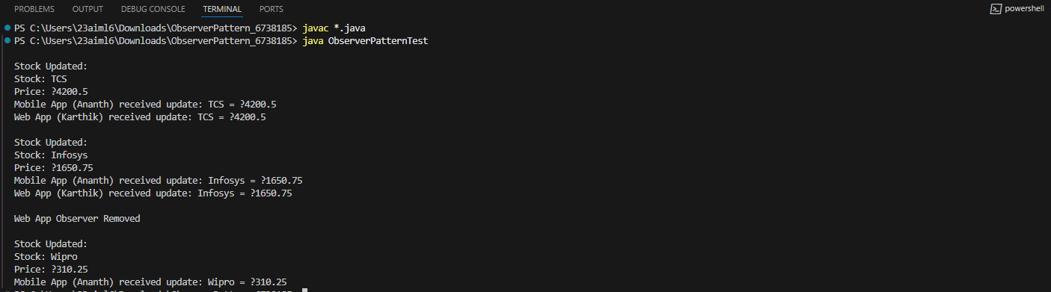
Exercise 8: Implementing the Strategy Pattern

Scenario:

You are developing a payment system where different payment methods (e.g., Credit Card, PayPal) can be selected at runtime. Use the Strategy Pattern to achieve this.

Code:

PaymentStrategy.java:

public interface PaymentStrategy {
void pay(double amount);
}

CreditCardPayment.java:

public class CreditCardPayment implements PaymentStrategy {
@Override
public void pay(double amount) {
System.out.println(
"Paid ₹" + amount +
" using Credit Card"
);
}
}

PayPalPayment.java:

public class PayPalPayment implements PaymentStrategy {
@Override
public void pay(double amount) {
System.out.println(
"Paid ₹" + amount +
" using PayPal"
);
}
}

PaymentContext.java:

public class PaymentContext {
private PaymentStrategy paymentStrategy;
public void setPaymentStrategy(
PaymentStrategy paymentStrategy) {
this.paymentStrategy = paymentStrategy;
}
public void makePayment(double amount) {
if (paymentStrategy == null) {
System.out.println(
"Please select a payment method."
);
return;
}
paymentStrategy.pay(amount);
}
}

StrategyPatternTest.java:

public class StrategyPatternTest {
public static void main(String[] args) {
PaymentContext context = new PaymentContext();
// Credit Card Payment
context.setPaymentStrategy(
new CreditCardPayment());
context.makePayment(5000);
// PayPal Payment
context.setPaymentStrategy(
new PayPalPayment());
context.makePayment(2500);
}
}

Output:

Exercise 9: Implementing the Command Pattern

Scenario:

You are developing a home automation system where commands can be issued to turn devices on or off. Use the Command Pattern to achieve this.

Code:

Command.java:

public interface Command {
void execute();
}

Light.java:

public class Light {
public void turnOn() {
System.out.println("Light is ON");
}
public void turnOff() {
System.out.println("Light is OFF");
}
}

LightOnCommand.java:

public class LightOnCommand implements Command {
private Light light;
public LightOnCommand(Light light) {
this.light = light;
}
@Override
public void execute() {
light.turnOn();
}
}

LightOffCommand.java:

public class LightOffCommand implements Command {
private Light light;
public LightOffCommand(Light light) {
this.light = light;
}
@Override
public void execute() {
light.turnOff();
}
}

RemoteControl.java:

public class RemoteControl {
private Command command;
public void setCommand(Command command) {
this.command = command;
}
public void pressButton() {
if (command != null) {
command.execute();
} else {
System.out.println("No command assigned.");
}
}
}

CommandPatternTest.java:

public class CommandPatternTest {
public static void main(String[] args) {
Light light = new Light();
Command lightOn = new LightOnCommand(light);
Command lightOff = new LightOffCommand(light);
RemoteControl remote = new RemoteControl();
remote.setCommand(lightOn);
remote.pressButton();
remote.setCommand(lightOff);
remote.pressButton();
}
}

Output:

Exercise 10: Implementing the MVC Pattern

Scenario:

You are developing a simple web application for managing student records using the MVC pattern.

Code:

Student.java:

public class Student {
private int id;
private String name;
private String grade;
public Student(int id, String name, String grade) {
this.id = id;
this.name = name;
this.grade = grade;
}
public int getId() {
return id;
}
public void setId(int id) {
this.id = id;
}
public String getName() {
return name;
}
public void setName(String name) {
this.name = name;
}
public String getGrade() {
return grade;
}
public void setGrade(String grade) {
this.grade = grade;
}
}

StudentView.java:

public class StudentView {
public void displayStudentDetails(int id, String name, String grade) {
System.out.println("Student Details");
System.out.println("---------------");
System.out.println("ID : " + id);
System.out.println("Name : " + name);
System.out.println("Grade : " + grade);
}
}

StudentController.java:

public class StudentController {
private Student model;
private StudentView view;
public StudentController(Student model, StudentView view) {
this.model = model;
this.view = view;
}
public void setStudentName(String name) {
model.setName(name);
}
public void setStudentGrade(String grade) {
model.setGrade(grade);
}
public String getStudentName() {
return model.getName();
}
public String getStudentGrade() {
return model.getGrade();
}
public int getStudentId() {
return model.getId();
}
public void updateView() {
view.displayStudentDetails(
model.getId(),
model.getName(),
model.getGrade());
}
}

MVCPatternTest.java:

public class MVCPatternTest {
public static void main(String[] args) {
Student student = new Student(101, "Ananth", "A");
StudentView view = new StudentView();
StudentController controller =
new StudentController(student, view);
System.out.println("Initial Details:");
controller.updateView();
controller.setStudentName("Karthik");
controller.setStudentGrade("A+");
System.out.println("\nUpdated Details:");
controller.updateView();
}
}

Output:
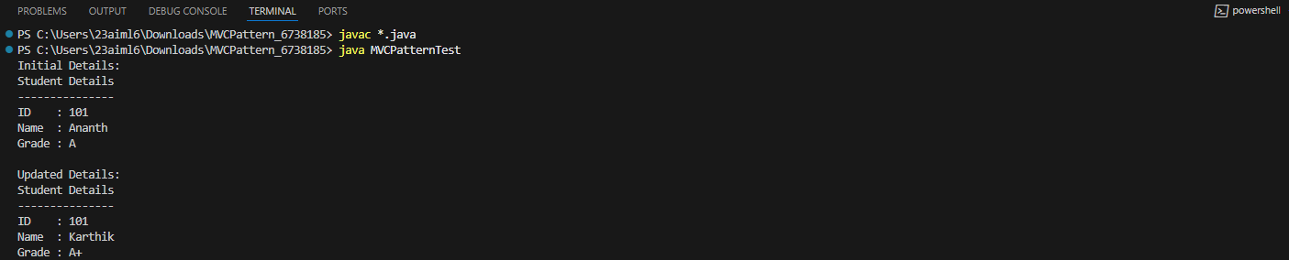
Exercise 11: Implementing Dependency Injection

Scenario:
You are developing a customer management application where the service class depends on a repository class. Use Dependency Injection to manage these dependencies.

Code:

CustomerRepository.java:

public interface CustomerRepository {
String findCustomerById(int id);
}

CustomerRepositoryImpl.java:

public class CustomerRepositoryImpl
implements CustomerRepository {
@Override
public String findCustomerById(int id) {
if (id == 101) {
return "Ananth";
}
return "Customer Not Found";
}
}

CustomerService.java:

public class CustomerService {
private CustomerRepository repository;
// Constructor Injection
public CustomerService(
CustomerRepository repository) {
this.repository = repository;
}
public void getCustomerDetails(int id) {
String customer =
repository.findCustomerById(id);
System.out.println("Customer ID : " + id);
System.out.println("Customer Name : " + customer);
}
}

DependencyInjectionTest.java:

public class DependencyInjectionTest {
public static void main(String[] args) {
// Create Repository
CustomerRepository repository =
new CustomerRepositoryImpl();
// Inject Repository into Service
CustomerService service =
new CustomerService(repository);
// Use Service
service.getCustomerDetails(101);
}
}

Output:

